**1. Volcker Rule**

**2. Retail Banking Operations**

**(Presented By Alan Stuart K)**

**1. Volcker Rule:**

**Introduction:**

The Volcker Rule is a key financial regulation that was introduced as part of the Dodd-Frank Wall Street Reform and Consumer Protection Act, which was enacted in response to the 2008 financial crisis. Named after former Federal Reserve Chairman Paul Volcker, the rule aims to prevent banks from engaging in risky investment activities that do not benefit their customers and could potentially destabilize the financial system. Specifically, the Volcker Rule restricts proprietary trading by commercial banks and limits their investments in hedge funds and private equity.

**Basic Terminologies:**

1. **Proprietary Trading:** This refers to when a bank or financial institution invests its own money in financial markets, rather than on behalf of its customers. The profits and losses from these investments are for the bank's own account.
2. **Dodd-Frank Act:** A comprehensive piece of financial reform legislation passed in 2010 in response to the financial crisis of 2008. It aims to reduce risks in the financial system through increased regulation and oversight of financial institutions.
3. **Commercial Bank:** A financial institution that offers a range of services including accepting deposits, providing loans, and offering basic investment products. Commercial banks primarily serve individuals and businesses.
4. **Hedge Fund:** An alternative investment vehicle that pools capital from accredited investors or institutional investors and invests in a variety of assets, often using complex strategies to achieve high returns.
5. **Private Equity:** A form of investment where funds are directly invested in private companies, or public companies that are taken private, typically through leveraged buyouts.
6. **Covered Fund:** A term defined under the Volcker Rule to include certain types of investment funds such as hedge funds and private equity funds that banks are restricted from owning, sponsoring, or having certain relationships with.
7. **Market Making:** The process by which a bank or financial institution provides liquidity to the market by being ready to buy and sell securities at any time. Market-making activities are allowed under the Volcker Rule if they meet specific criteria to ensure they are not proprietary trading.
8. **Risk Mitigating Hedging:** Transactions that banks engage in to reduce or mitigate specific risks arising from the bank’s individual or aggregate positions. The Volcker Rule allows for risk-mitigating hedging activities provided they meet stringent requirements.

**Graphs:**

**Graph 1.A:** Proprietary Trading Volume of US Banks Over Time:

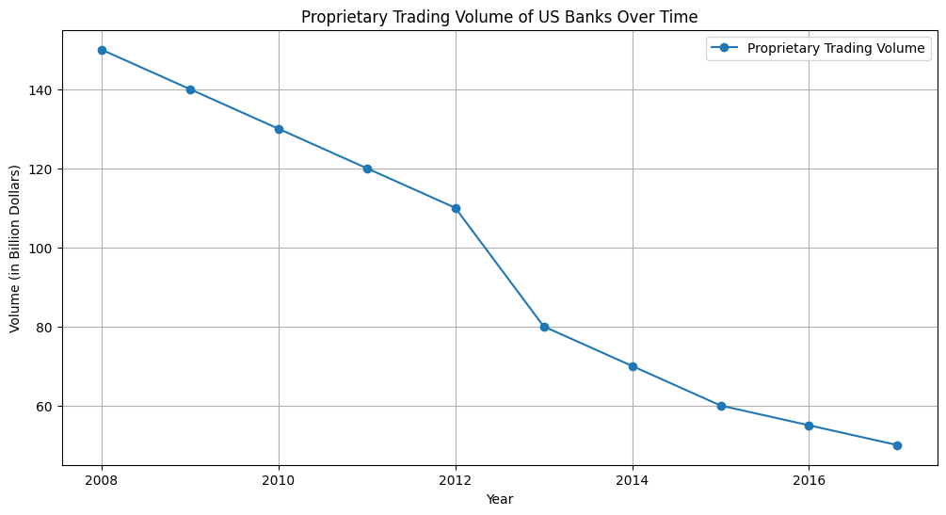**Inference:** The graph shows a significant decline in proprietary trading volumes starting from 2013. This is likely due to the implementation of the Volcker Rule, which restricted banks from engaging in proprietary trading. The rule aimed to reduce risky speculative trading activities and ensure that banks focus on serving their customers rather than engaging in high-risk investments.

**Graph 1.B:** Trading Revenue of US Banks Over Time:

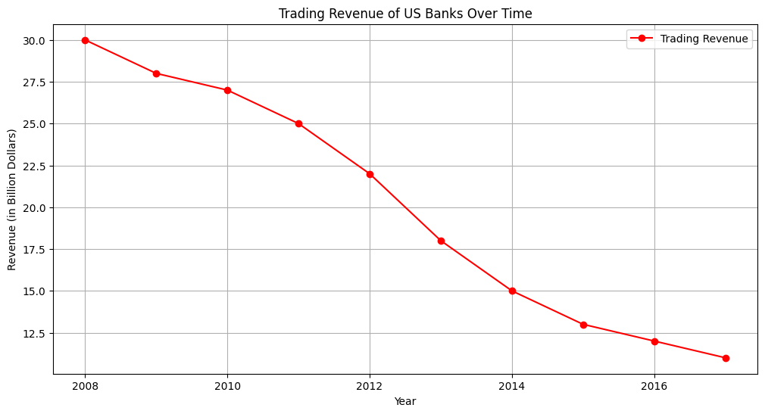**Inference:** Similar to the proprietary trading volume, the trading revenue of US banks also shows a noticeable decline post-2013. This indicates that the restrictions imposed by the Volcker Rule had a direct impact on the revenue banks generated from trading activities. The decline in trading revenue reflects the banks' reduced ability to engage in speculative trading, thereby lowering their risk exposure.

**Graph 1.C:** Return on Assets (ROA) of US Banks Over Time:

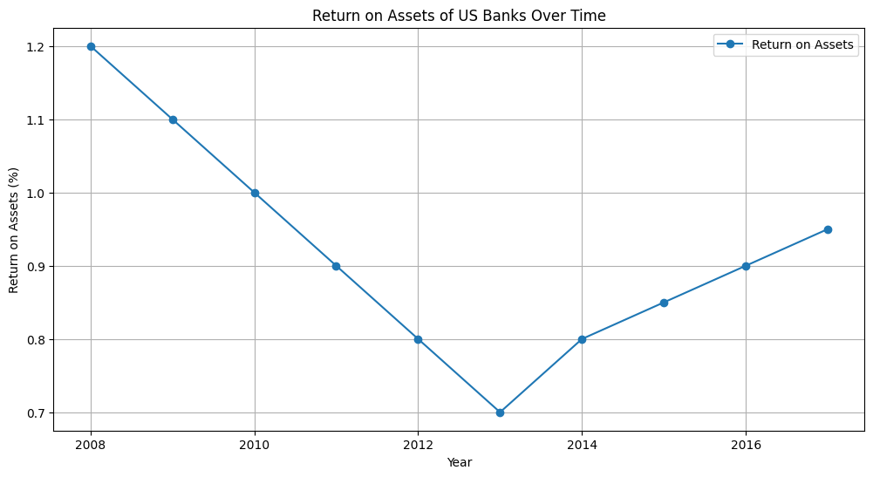

**Inference:** The Return on Assets (ROA) initially declines post-2013 but then starts to stabilize and improve slightly. This trend suggests that while the Volcker Rule initially impacted banks' profitability, over time, banks adapted their business models and operations to maintain and even improve their profitability. The stabilization and subsequent improvement in ROA could be attributed to banks focusing more on core banking activities and improving operational efficiency.

**Graph 1.D:** Capital Reserves of US Banks Over Time:

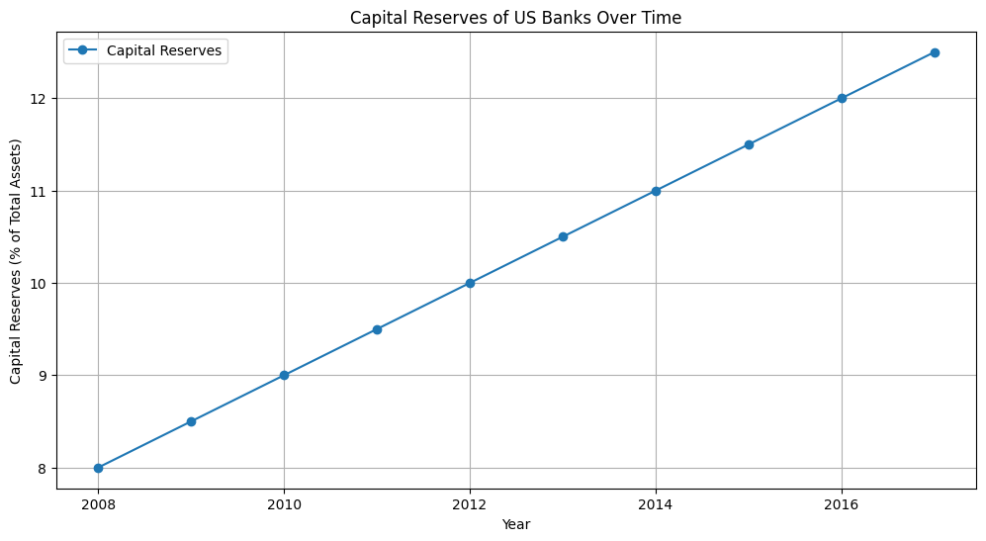**Inference:** The capital reserves of US banks show a steady increase over the years. The implementation of the Volcker Rule and other regulatory measures post-2008 financial crisis aimed at increasing the financial stability of banks. The increase in capital reserves indicates that banks are holding more capital relative to their total assets, making them more resilient to financial shocks and reducing the risk of insolvency.

**2. Retail Banking Operations:**

**Introduction:**

Retail banking, also known as consumer banking, refers to the provision of financial services by banks to individual consumers rather than businesses or large institutions. Retail banking services include checking and savings accounts, mortgages, personal loans, credit cards, and more. The sector has undergone significant changes with the advent of digital banking technologies, which have transformed how customers interact with their banks and manage their finances.

**Basic Terminologies:**

1. **Branch Banking:** The traditional form of banking where customers visit physical bank branches to conduct transactions and access banking services.
2. **Digital Banking:** The provision of banking services through digital channels such as the internet and mobile applications. Digital banking allows customers to perform a wide range of banking activities online.
3. **Mobile Banking:** A subset of digital banking that specifically refers to the use of smartphones and mobile applications to access banking services and perform transactions.
4. **ATM (Automated Teller Machine):** An electronic banking outlet that allows customers to complete basic transactions without the need for a branch representative. ATMs provide services such as cash withdrawals, deposits, and balance inquiries.
5. **Customer Satisfaction:** A measure of how products and services provided by a bank meet or exceed customer expectations. High customer satisfaction is often associated with customer loyalty and positive word-of-mouth.
6. **Return on Assets (ROA):** A financial metric that indicates how profitable a bank is relative to its total assets. It is calculated by dividing net income by total assets. ROA is an indicator of how efficiently a bank is using its assets to generate earnings.
7. **Capital Reserves:** Funds that banks set aside to cover potential losses and ensure financial stability. These reserves are a key component of a bank's safety and soundness, providing a buffer against unexpected financial shocks.

**Graphs:**

**Graph 2.A:** Number of Bank Branches Over Time:

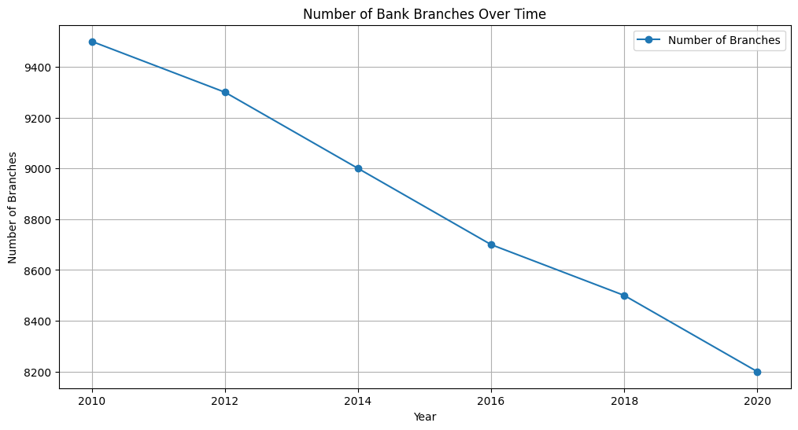**Inference:** The graph shows a gradual decline in the number of bank branches over the years. This trend reflects the shift from traditional brick-and-mortar banking to digital banking. As customers increasingly adopt online and mobile banking, banks are reducing their physical branch networks to cut costs and focus more on digital service delivery.

**Graph 2.B:** Digital Banking Adoption Over Time:

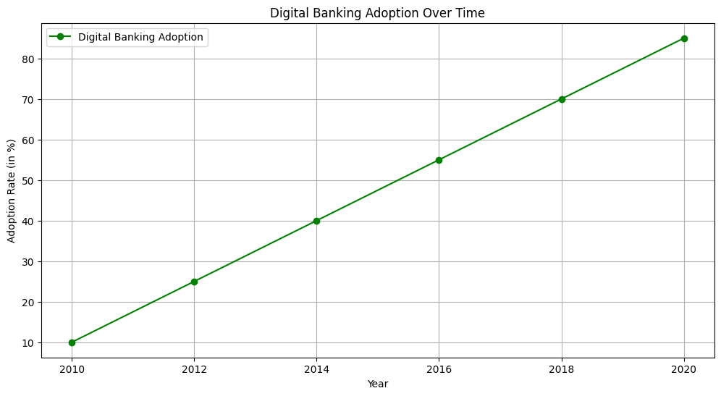

**Inference:** The adoption of digital banking services shows a sharp increase over the years. This trend highlights the growing preference for digital banking solutions among customers. The increase in digital banking adoption is driven by advancements in technology, the convenience of online and mobile banking, and changing consumer behaviours towards more digital interactions.

**Graph 2.C:** Customer Satisfaction Score Over Time:

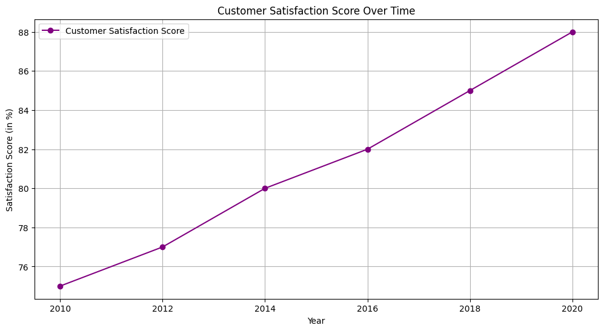**Inference:** The customer satisfaction score shows a steady improvement over the years. This indicates that banks' efforts to enhance their digital banking services and customer service are being positively received by customers. The improved satisfaction scores reflect better customer experiences, more efficient services, and the effective use of technology to meet customer needs.

**Graph 2.D:** ATM Usage Over Time:  
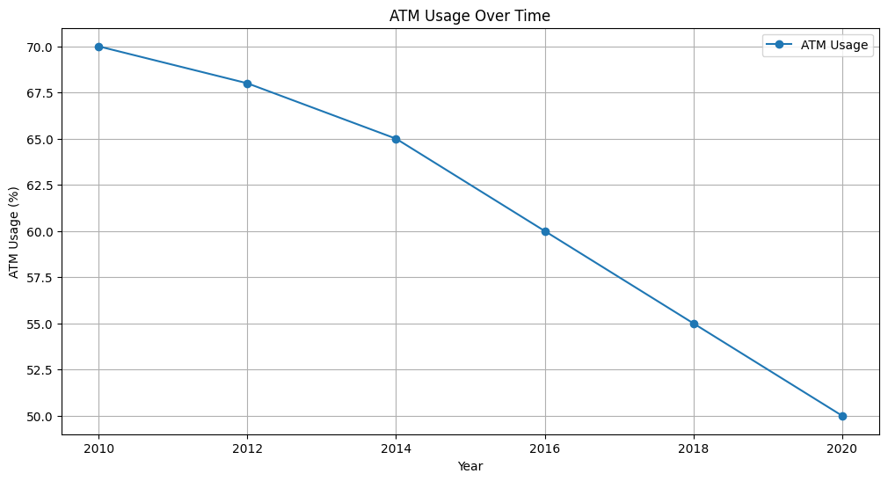**Inference:** The usage of ATMs shows a declining trend, indicating a reduced reliance on cash transactions and traditional banking methods. As digital and mobile banking solutions become more prevalent, customers are less dependent on ATMs for their banking needs. This trend further supports the shift towards digital banking and the move away from physical banking infrastructure.

**Conclusion:**

The Volcker Rule and the evolution of retail banking operations represent significant shifts in the US banking sector driven by regulatory and technological advancements. The Volcker Rule, by restricting proprietary trading and investments in hedge funds and private equity, has reduced systemic risk and enhanced financial stability, as evidenced by the initial decline in trading activities and the subsequent stabilization of financial metrics. Concurrently, the retail banking sector's transition to digital platforms, reflected in the decline of physical branches and ATM usage, underscores the increasing consumer preference for convenient and accessible banking solutions. The rise in digital banking adoption and mobile app usage, along with improving customer satisfaction scores, highlights the success of banks in adapting to these changes and meeting customer needs. Together, these developments illustrate the crucial balance between regulatory oversight and technological innovation, fostering a safer financial system and more efficient, customer-centric banking services.